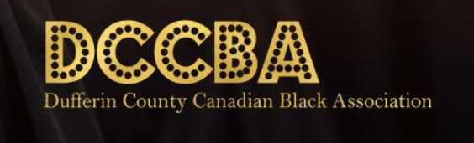

The Dufferin County Canadian Black Association (DCCBA), launched in June 2020 and headquartered in Shelburne, is a non-profit organization whose mission is to demonstrate leadership and advocacy, provide relevant education, resources, and training to enhance, elevate and celebrate Black communities in Dufferin County.

The DCCBA envisions a Dufferin County where Black communities have equitable access to all opportunities and resources to improve their quality of life, participate in, and contribute to the development and growth of society. The work we do and our engagement with the community are guided by the following values:

**Education**: We promote education as the primary vehicle to economic mobility and sustainability for our community.

**Integrity**: We lead with integrity in all aspects of our work - demonstrating honesty and moral change.

**Excellence**: We expect and deliver the very best whenever representatives of the DCCBA are involved.

**Advocacy**: We take active and measurable steps to influence decisions within political, economic, and social institutions.

**Diversity & Inclusion**: We serve as a champion for and live out diversity and inclusion at all times.

**Transparency**: We stay accountable to members of the community.

**Collaboration**: We recognize that the path toward equity requires working together with all community partners.

**Programs and Events**

**EVENTS**

Black History

Month

International Women’s Day

Information Sessions

**COMMUNITY ENGAGEMENT**

Ask the Experts

Financial Literacy Workshops

Training Workshops

**CIVIC ENGAGEMENT**

Entry to Municipal Politics

**EDUCATION**

Scholarship Program

Tutoring

Coding

Tri-SAS Drop-in Program